Demonstrate how monitors are used.

Step-1:

First I open postman

Step-2:

Click on 3 dots and then click on Moniter Collection

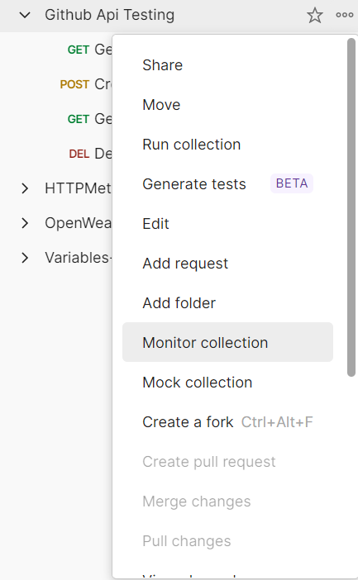

Step-3: Then give a moniter name

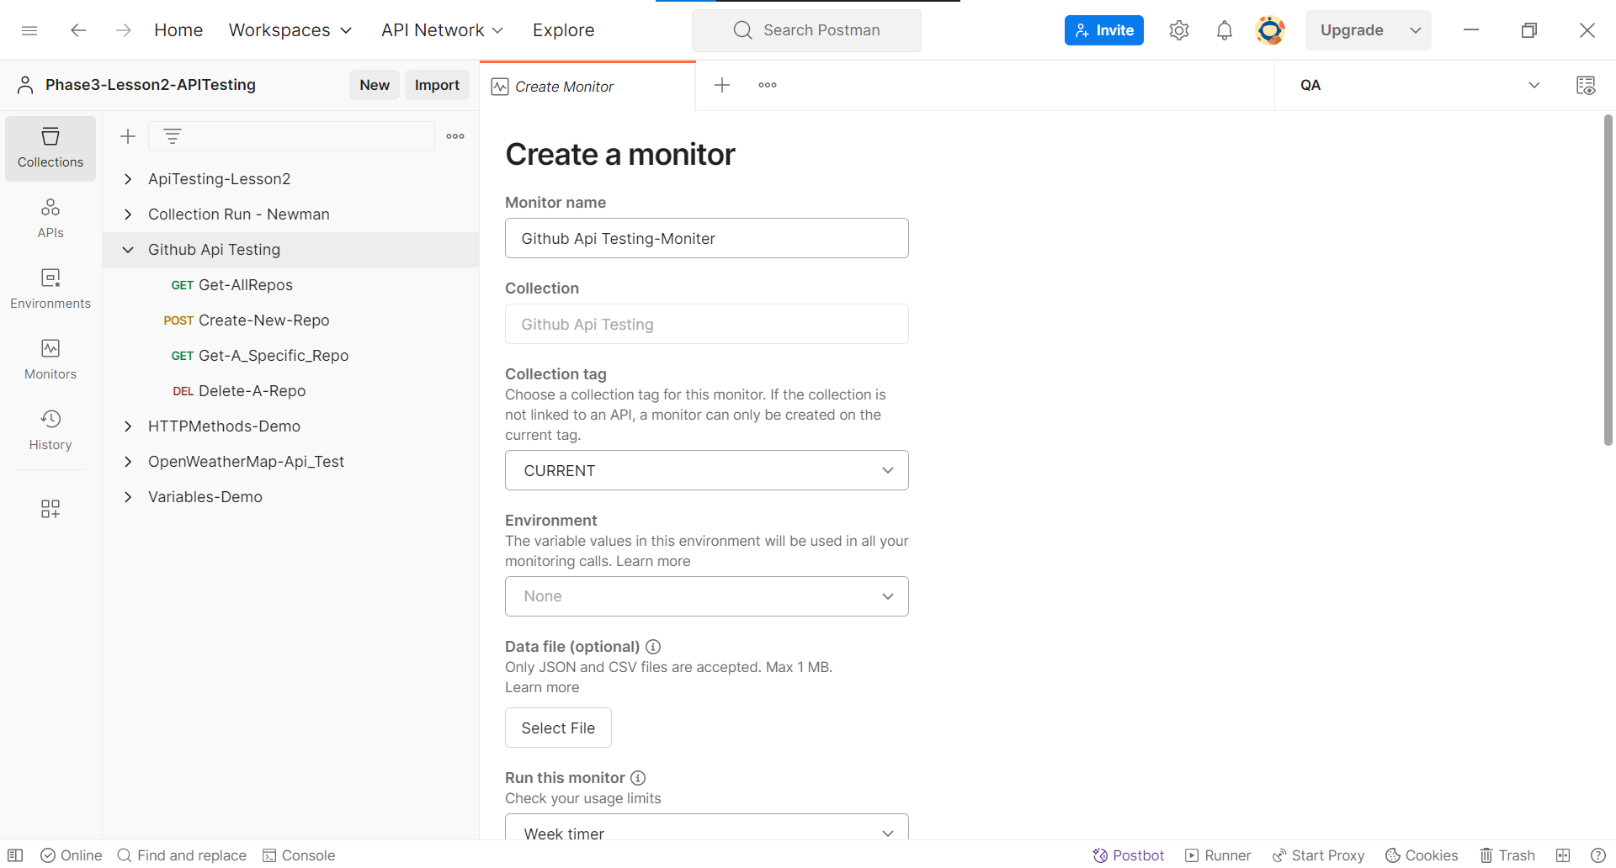

Step-4: Then I click on Create Moniter

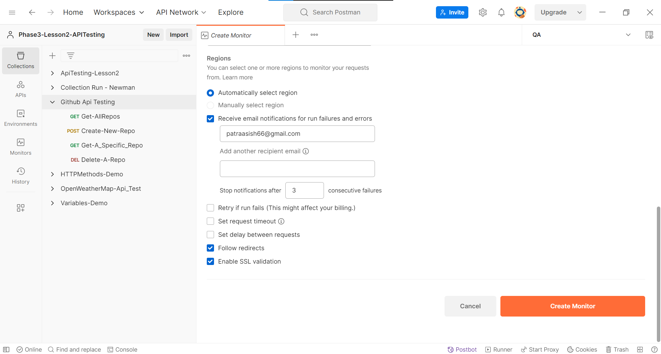

Step-5:

Then I click on run

